A* ALGORITHM

AIM: To implement a python program for A* Algorithm.

OBJECTIVES:
- To implement the A* search algorithm using Python.
- To find the shortest path between a start node and a goal node.
- To understand the use of cost g(n) and heuristic h(n).
- To calculate the total cost using f(n) = g(n) + h(n).
ALGORITHM:
- Start from the initial node.
- Add the start node to the open list.
- Calculate the cost f(n) = g(n) + h(n).
- Select the node having the smallest f(n).
- If the selected node is the goal, stop and display the path.
- Otherwise, find its neighbouring nodes.
- Calculate the cost of each neighbour.
- Add the unvisited neighbours to the open list.
- Repeat until the goal is reached.
- Display the shortest path and its total cost.
SYSTEM-ARCHITECTURE:
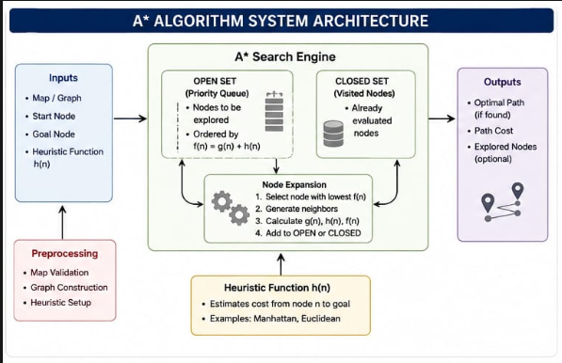

PROGRAM:
graph = {
'A': [('B', 1), ('C', 3)],
'B': [('D', 1), ('E', 5)],
'C': [('E', 2)],
'D': [('G', 3)],
'E': [('G', 1)],
'G': []
}

h = {'A': 5, 'B': 4, 'C': 3, 'D': 2, 'E': 1, 'G': 0}

open_list = [(h['A'], 0, 'A', ['A'])]

while open_list:
f, cost, node, path = min(open_list)
open_list.remove((f, cost, node, path))

if node == 'G':
print("Shortest Path:", path)
print("Total Cost:", cost)
break

for next_node, edge_cost in graph[node]:
new_cost = cost + edge_cost
new_f = new_cost + h[next_node]
open_list.append((new_f, new_cost, next_node, path + [next_node]))

OUTPUT:
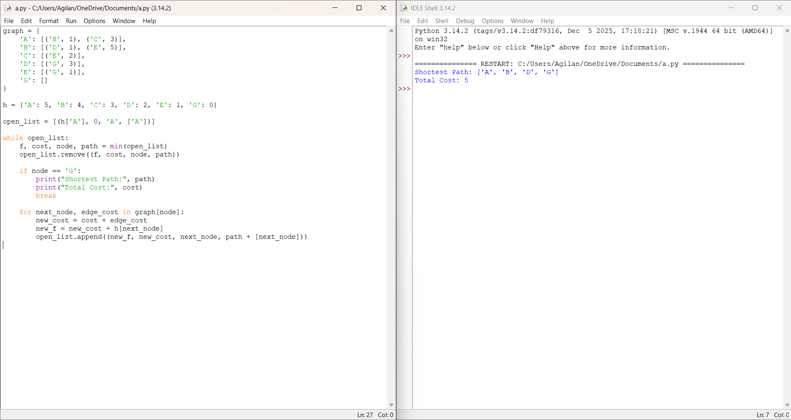

RESULT: Thus the A* Algorithm is implemented successfully using python language.

